**PEOPLE’S COMMISSARIAT OF FOREIGN AFFAIRS**

**UNITED SOCIALIST REPUBLICS**

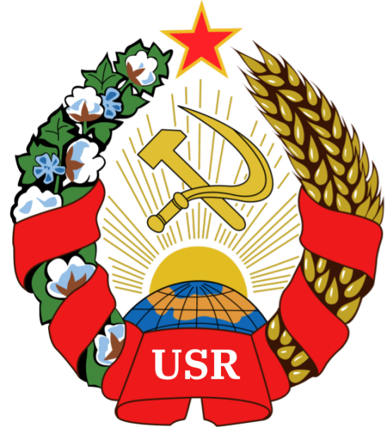

**Admission of the Kingdom of Commack**

**Author:** Comrade GENERAL PRESIDENT TIZIAN ARUNA

**Sponsored by:** The People’s Commisariat for Foreign Affairs

Hereby releases this document to the public.

**Article One:**

The Kingdom of Commack is hereby fully admitted into the United Socialist Republics

**Article Two:**

The Kingdom of Commack falls under the status of an AUTONOMOUS REPUBLIC of the U.S.R, with no protector nation.

**Article Three:**

The Kingdom of Commack fully adheres to the Autonomous Republic Framework and the [Treaty of Foundation of the U.S.R](https://docs.google.com/document/d/1S4DzTfhO9nucFmvHbE7qrON4LkDAC4MwuCYWn47vanQ/edit)

**Article Four:**

Transmit to the NATIONAL ASSEMBLY OF THE U.S.R and to any relevant authorities

**SIGNED:**

**General President Tizian Aruna**



**NATIONAL SEAL**

**GRANTED**